Discussion Notes
MAIN FOCUS
How can the climate resistant coral farming initiative be developed and what are the environmental and social welfare implications?
How to become more sustainable environmentally and economically?

Basic Idea of the class
- Search for common problems and template solutions
- “Professionalize” one or more elements of the ecosystem
- Use technology to enhance productivity

Two main points
- Identification of climate resistant coral
  - Identify the economic reasons for finding climate resistant coral
  - Where should the coral be extracted and farmed from
- Long term consequences of farming climate resistant coral?

Role as a group is to support the science group from Stanford
- Communication is with an intermediary

An approach to classifying differences – CAGE Model

Cultural Distance
- Language, religion, social structures, values, interpersonal relations, orientation to time
- The degrees of separation between differing cultures

Administrative Distance
- Institutions, political systems, organizational structures, hierarchy
- Moreso how the country itself is organized

Geographical Distance **(not as important for this class)

Economic Distance
- Income and growth, income distribution
- Helps us understand economic health between countries and how we promote products differently between countries

Indonesia Culture:
- Vastly multi-ethnic
- Language = significant barrier for us
  - 80% speak Indonesian
  - 10-30% of population speak English
    - Taxi drivers typically don’t speak English
- Primarily Sunni Muslim
  - Is considered a secular country
- 4th largest world pop. (273 million)

Etiquette, Social Status, Time Orientations
- Typically more formal, hierarchical, and conservative
  - Address sponsors as Pak Indra, Pak Eddy, Pak Fredrick, or Ibo Anne, Ibo Lia
    - Men are Pak [name]
    - Women are Ibo [name]

  - Avoid informal terms like “you guys”
- Public conduct is more traditional
  - Dress more “conservatively”
  - Secular society
- Time orientation differs slightly
  - Clock difference: 21 hours ahead. Can meet either early AM or Evening
  - On average less concerned about strictly adhering to schedules
    - More lax

Administrative Distance
- Government system structurally similar to U.S.
  - Executive, legislative, judiciary
  - President is Pak. Joko Widodo (PDI-P party)
- Global Political Alignment
  - Relatively neutral in the US vs China trade issues
- More oligarchical (In principle is a democracy)
  - Causes less emphasis on education
    - Low amount of high level universities
**Corruption is a challenge**

Economic Distance
- Indonesia has a relatively low medium age
  - Means a high potential for economic growth

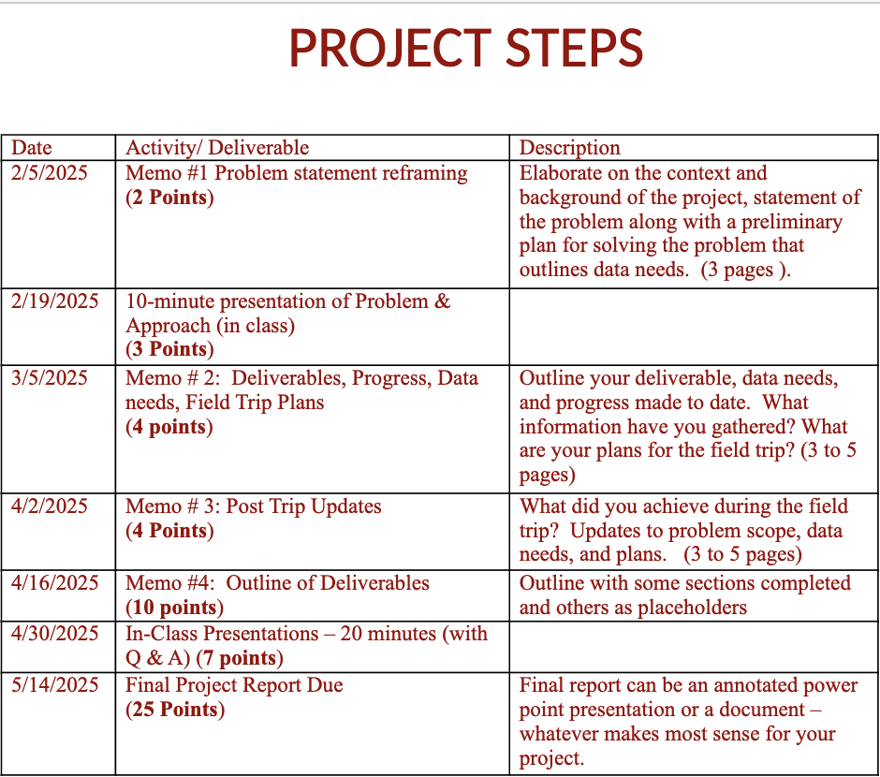

Data Science and Sustainable and Inclusive Growth

Technology and Trade and the Lower Part of the Economic Pyramid
- Poverty → reduced globally
- Trade increased technology access
- Technology increased market access and productivity

- Livelihood of the bottom 10% has increased substantially from 40 years ago
  - Improvements of food, technology, medicine have all contributed towards better quality of life

Trade and Technology don’t help everyone equally
- Beginning to be a larger gap in wealth inequality between rich and poor
  - Groups have begun separating further away from each other in terms of wealth
- Trade and technology are mainly responsible for this growing disparity between the groups

On a long term basis- arbitrage in the workforce isn’t actually occurring and people being displaced from the workforce have harder times being absorbed back into it

In the US Work available is shifting to those with higher skills
Ex: computer science market currently → becoming increasingly difficult to actually land a job in the current market

The income disparity between higher and lower education and higher and lower income workers has continued to increase over time

How to Create Scale?
- Need entities to create collaboration
  - For commodities, cooperatives have successfully acted as organizers to create collaboration
- Need pipelines to drive research and development at universities
- Need business to deploy technology solutions and professionalize services

Differentiated Products
- Food services
- Retail
- Services
- Goods

Inductive Research
- Qualitative approach
- Question based approach

Asking Questions
- Conversation (ethnographers)
  - Unstructured
  - Insight, new theory
  - Not a lot of pre-knowledge
  - Responses are unfamiliar
  - Open-ended questions (not yes or no questions)
- Interview (journalists)
  - Structured
  - Theory testing
  - Lot of pre-knowledge
  - Responses = familiar
  - Closed-ended questions (can be yes or no)

When conducting interviews
- What is their motivation
- Who do they think I am
- What is the purpose
- Who is the person
- What is the role that person is playing
- How would they react to the question
- Their reaction to how they’re being perceived

How we approach a situation depends on
- Social influences and pressures
- Values and priorities
- Problem solving strategies
- Knowledge and beliefs

How can you minimize your bias in inductive research?
- Social and Psychological Theories for Effective Questioning
  - Understanding human behavior helps us ask better questions without bias accurately
  - Theory of Mind and Perspective-Taking
    - Idea: People have different knowledge, beliefs, and experiences
    - Application: Avoid assumptions, seek explanations
      - *** Should be more interested in their hypotheses and their assumptions in our questions
  - Cultural Dimensions Theory (Hofstede)
  - Societies differ in power distance, collectivism, uncertainty avoidance
      - Implications
        - High power-distance cultures may defer to authority
        - Collectivist cultures may frame answers in terms of community experience
  - Social Identity Theory and Stereotype Threat
    - People shape responses based on how they perceive the interviewer
    - Risk
      - Interviewees may exaggerate or suppress info to align with expectations
    - Solution
      - Build trust, avoid leading questions
  - Narrative Identity Theory (McAdams)
    - People construct identities through stories
    - Application
      - Encourage storytelling rather than fact-based responses
  - Linguistic Relativity and Framing Effects
    - How a question is framed influences responses
    - Avoid abstract, technical, or leading questions

3 types of trust
- Benevolence
- Competence
- Understanding

*** Interviews
- Briefly describe/remind subject what you are working on
- Restate key points in the interviewee’s own words
- Ask easier questions earlier, after a difficult question – pause and listen
- Avoid yes/no questions unless essential
- (Never ask for info in an interview that you could collect elsewhere)

Grand Tour Questions and Prompts
- Ask the respondent to provide a verbal tour – walk the interviewer through something
  - “Can you walk me through …”
  - “Can you explain step-by-step how…”

Structuring the Research Process
- Preparation: Research local context, refine questions
- Building trust: Start with informal conversation
- Adaptive Questioning: Reframe vague or rehearsed answers
- Analysis and Reflection: Identify patterns, compare findings

Init Dev (Memo)
MAIN FOCUS
How can the climate resistant coral farming initiative be developed and what are the environmental and social welfare implications?
How to become more sustainable environmentally and economically?

How to economically start implementing the new methodology for farming climate resistant coral

Basic Idea of the class
- Search for common problems and template solutions
- “Professionalize” one or more elements of the ecosystem
- Use technology to enhance productivity



Possible Areas for Initiative Development

Coral Research Notes

Papers on Heat Resistant Coral

Notes from Q&A with Steve Palumbi

- Due to rising ocean temperatures coral has been dying out due to coral bleaching
  - Coral Bleaching is a process where corals die by spitting out their internal algal after being confronted with heat waves, causing an extreme lack of energy, leading to them dying and crumbling away
    - They get most of their energy from that internal algae as it collects it during photosynthesis

- Immediate threat to Coral Reef (Need Reef is in current danger due to global warming)
- There are variations in how coral react to the rising temperatures
  - Selective breeding and crossbreeding seem plausible but hard to upscale
  - Also very recently developed
- New work suggests you can influence coral to spit out their current crop of algae and modify it to take up more heat resistant algae
- Necessity to spread more information on the topic besides just researchers and reporters

Helping Coral reefs adapt to a warming ocean

- Developing new low-cost method to test coral heat resistance
- Coral has a symbiotic relationship with algae
  - Coral supplies algae with ingredients necessary for photosynthesis and algae provides the coral with energy from the photosynthesis process
- Tested by bringing coral pieces back to a lab and artificially raised water temperatures to mimic the effects of warming oceans due to climate change
Article doesn’t state much about how they actually are planning on making it more cost-effective

Coral’s Adaptive Response to Climate Change

- Symbiont communities = group of organisms that are in close, long-term relationship with one another
  - In this context, the symbionts are the algae and their thermal tolerance determine how much resistance they and the coral have towards climate change and increased heat levels

- Long-term response of coral reefs to climate change depends on the ability of reef-building coral symbioses to adapt or acclimatize to warmer temperatures
  - No direct evidence such a response can occur
- Coral containing unusual algal symbionts that are thermally tolerant and commonly associated with high-temperature environments are much more abundant on reefs that have been affected by recent climate change
  - Points towards these previously devastated reefs could be more resistant to future thermal stress
    - Leads to longer extinction times for surviving corals than previously assumed
  - Process of these symbiont shifts occurring is yet to be found and it is possible the affected reefs may revert back to their previous symbiont communities if they don’t experience repeat warming episodes
- Coral containing different symbionts can vary in their sensitivity to coral bleaching
  - Can modify their symbiont communities in response to environmental change

Mechanisms of Reef Coral Resistance to Future Climate Change

- Local acclimatization and fixed effects, such as adaption, contributed roughly equally towards heat tolerance and are reflected in patterns of gene expression
  - In less than 2 years, acclimatization achieves the same heat tolerance expected from strong natural selection over many generations
    - Study shows both short-term acclimatory and longer-term adaptive acquisition of climate resistance
- Corals in naturally warm environments can have higher resistance to bleaching temperatures and survive heat exposure longer than coral living in cooler climates
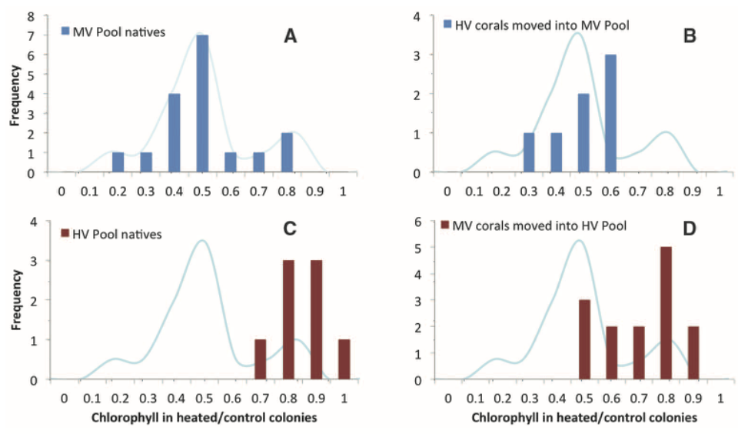
- Serves as a visualizer for what was stated previously
  - MV pool = pool that was relatively cooler and rarely experienced temps above 32ºC
  - HV pool = pool that had higher variability, often exceeding 30ºC and reached 35ºC
    - Showcased that corals acquired a part of the heat sensitivity of the pool they got transplanted into
      - Higher retention of chlorophyll when transferring from MV to HV pool
      - Lower retention of chlorophyll when transferring from HV to MV pool
      - MV pool corals that got relocated did acquire heat resistance, however not to the same resistance of native HV corals
      - HV pool corals that got relocated dropped their chlorophyll retention to the same level as the MV pool natives
- Studies show that acclimatization can allow corals to acquire substantial high-temperature resistance faster than natural selection would produce

Papers on the Economic Benefit of Healthy Coral Reefs

"Economic Values of Coral Reefs, Mangroves, and Seagrasses" by the World Resources Institute (2002)

- Provide economic goods and services and contribute to livelihoods of people around the world
- Jan 2008, International Coral Reef Initiative (ICRI) established an Ad Hoc Committee on Economic Valuation of Coral Reef Ecosystems
  - Co-chaired by Mexico-United States ICRI Secretariat and World Resources Institute (WRI)
- Booklet serves as a summary of results from wide variety of economic valuation studies on coral reefs and related ecosystems

- Areas of focus
  - Tourism
    - People visit coral reefs to enjoy opportunities provided by ecosystems (SCUBA diving, snorkeling, etc.)
  - Fisheries
    - Coral reefs provide important fish habitat
  - Coastal Protection
    - Serve as natural barriers to storm surges
  - Biodiversity
    - The UN’s Atlas of the Ocean describes reefs as among most biologically rich ecosystems
      - 4,000 species of fish and 800 species of coral
  - Carbon Sequestration
    - Remove carbon dioxide from atmosphere

Global, Regional, and Site-Specific Values
- Total net benefit per year from world’s coral reefs = $29.8 billion
  - Tourism and recreation = $9.6 billion
  - Coastal protection = $9.0 billion
  - Fisheries = $5.7 billion
  - Biodiversity = $5.5 billion
- Avg annual value = just over $2,800 per hectare

Southeast Asia
- Total potential sustainable annual economic net benefits per km² of healthy coral reef in SEA estimated ranging from $23,100 to $270,000

Indian Ocean (Indonesia Focus)
- Using a dynamic simulation model, analyzed Total Economic Value (TEV) of Leuser National Park from 2000-2030.
  - Not much information regarding size of coral reef in the national park
    - Leuser national park size is 1,094,692 hectares
  - w/ 4% discount rate, accumulated TEV during period (30 yrs) =
    - $7.0 billion under deforestation scenario (extreme low)
    - $9.5 billion under conservation scenario (extreme high)
    - $9.1 billion under selective utilization scenario (middle)
    - ***Water supply, flood prevention, tourism, and agriculture contributed the most in the conservation and selective utilization scenarios

Pacific Ocean (Indonesia Focus)
- Potential sustainable economic net benefits per year from coral reefs
  - $1.6 billion
- In Indonesia’s Wakatobi National Park in Southeast Sulawesi was estimated:
  - $308,000 or $12,100/km²
- Net present value over 20 years w/ 10% discount rate is estimated
  - $2.6 million
  - Fisheries produced an average of $10,340 per km² annually
    - Present Value (PV) of over $2.2 million, calculated over 20 years with a 10% discount rate
  - Eco-tourist revenues provided almost $1,320 per km² in 2004
    - Expected PV = $286,000
  - Indirect benefit of coastal protection $1320 annually or $473 per km²

- Quantifiable net benefits of managing Taka Bone Rate Marine Protected Area (MPA)
  - Estimated between $3.5 and $5 million in Net Present Value terms, at a 10% discount rate over 25 years

Study analyzing costs and benefits of coral mining in Lombok, Indonesia (could use this as a substitute calculation for coral dying due to heat)
- Two scenarios
  - LOW: limited tourism potential and little coastal construction
  - HIGH: high tourism potential and coastal infrastructure
    - All calculated using Net Present Value terms for 30-year time horizon
  - Economic loss found: $33,000 per km² for “LOW” scenario
  - Economic loss found: $762,000 per km² for “HIGH” scenario
  - Both scenarios resulted in significant, long-term loss for society
    - Loss from fisheries
      - $74,900 in both
    - Loss from tourism
      - $2,900 in “LOW”
      - $481,900 in “HIGH”
    - Loss from coastal protection
      - $12,000 in “LOW”
      - $260,000 in “HIGH”

Ecosystems Goods and Services

Tourism
- Pulau Weh (MPA)
  - Contributed more than 60% to regional GDP
  - $230,000 in entrance fees per year
  - Residents willing to pay $13.60 per household per year to preserve marine park
  - Estimated people involved in nature-based tourism near MPA had annual per capita income of $216 compared those in other sectors
- Bunaken National Park
  - In 1st year between March and December 2001 = 15,055 visitors → 5183 foreigners
    - Totaling $42,000 in entrance fees
    - Entrance fee doubled in 2002
      - Totaled $110,000 from 25,697 visitors

Fisheries
- Leuser
  - 2001, coastal fisheries and aquaculture in and around exceeded $171.0 million
  - Avg share of fishery sector dependent on Leuser estimated
    - 2% maritime fishery
    - 9% brackish water fishery
    - 100% brackish and freshwater aquaculture

Degradation or Loss of Ecosystem Services Values
- 2002, more than 32,000 km² of reefs were overfished
  - Losses estimated at $1.9 billion over 20 years

Coral Reef Economy

- Analysis found a healthy coral reef scenario is expected to deliver additional economic benefits totaling to $34.6 billion and $36.7 billion in the Mesoamerican reef and Coral Triangle, respectively, between 2017 and 2030

Coral Triangle INCLUDES INDONESIA
MESOAMERICA DOESN’T

Key Findings
- Coral reefs underpin significant economic value for private sector
  - ***Value it linked to their health
  - Current value
    - $6.2 billion per annum in Mesoamerica
    - $13.9 billion per annum in Coral Triangle
      - If continued declining, value could fall by $3.1 billion and $2.2 billion respectively by 2030

- Value of Future Healthy Coral Reefs if High
  - Shift towards healthy state could unlock additional value/revenue from the reefs
    - Potential returns highlight the financial business case for the private sector to invest in coral reef health

- Societal Co-Benefits of Healthy Coral Reefs Could Exceed Private Gains
  - Results of study should be taken as a component in the total value which includes the broader economic, social, and environmental benefits of reef protection

- Policies to Enhance Coral Reef Health Generate a Financial Return on Investment
  - Policies are available to help produce financial benefit from protection of the reefs

- Interventions to Protect Coral Reefs Contribute to the Sustainable Development Goals
  - Action to enhance the health of coral reefs will help deliver the 2030 Development Agenda and SDGs (sustainable development goals)

- Climate Change Poses Significant Risk and Adds Uncertainty
  - Efforts to enhance coral reef must be considered within long-term context of climate change

Economic Value of Coral Reefs Today
- Fig 1 and Table 1:
  - Presents the contributions of each sector to total estimated economic returns in each region
  - Direct Economic Impact:
    - Tourism
    - Commercial fisheries
    - Coastal development
  - Indirect Economic Impact:
    - Spending by each of these sectors on goods and services in other sectors where they depend on resources
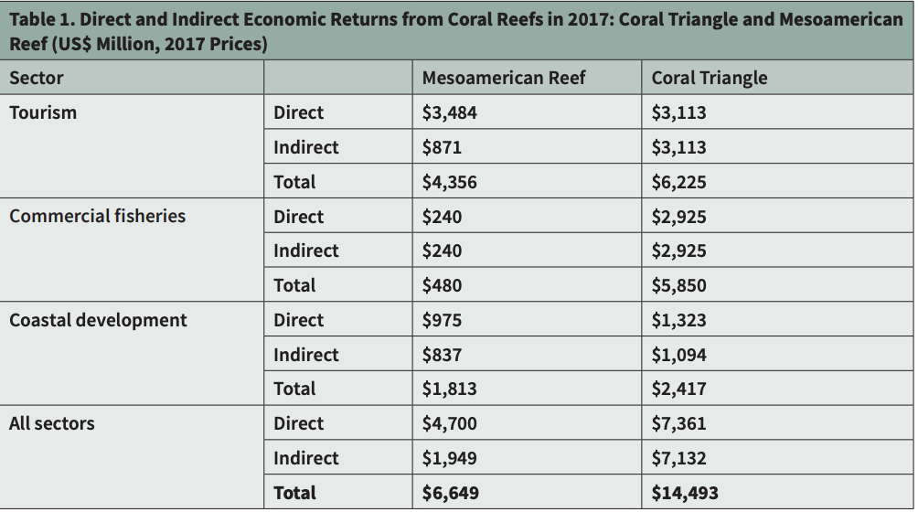
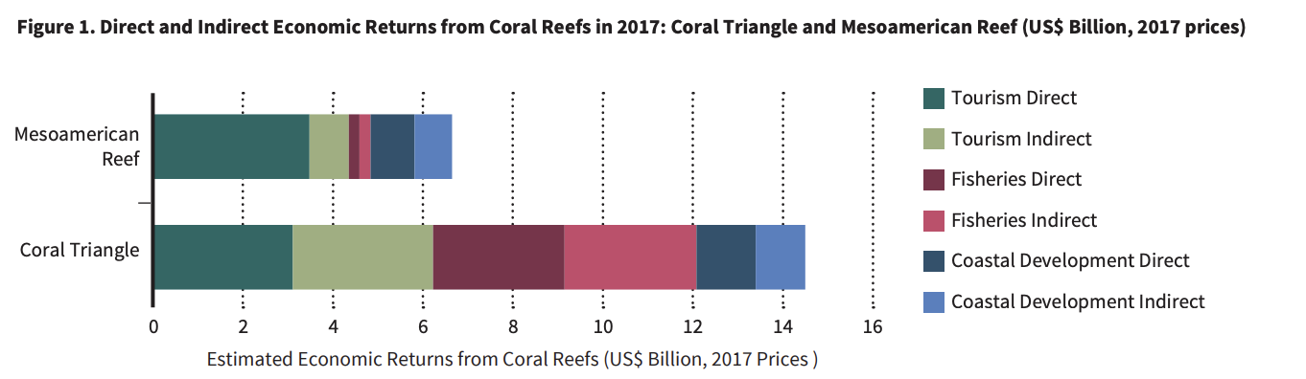

- Results reflect the differences in economic composition of countries in each region

Scenario Analysis: Economic Value of Healthy and Degraded Reefs
- Presents a modelled comparison of expected future returns to each of the key sectors between 2017 and 2030 under a Healthy vs Degraded Reef Scenario
  - Degraded Scenario:
    - Continued decline of the reefs
    - What will happen to the reefs if preventative measures aren’t taken
    - Live Coral Cover assumed to decline from an average of 3.7% in 2017 to 1.6% in 2030 in Mesoamerica
      - 16.6% to 11% in Coral Triangle
  - Healthy Scenario:
    - Reef recovered linearly over time
    - Healthy target determined based on other scientific studies
    - Live coral cover assumed to increase to 14.1% in Mesoamerica by 2030
      - 36.4% in Coral Triangle by 2030
- Fig 2 and Table 2
  - Present annualised present value of economic returns from key sectors in Mesoamerica (2017-2030) under both scenarios
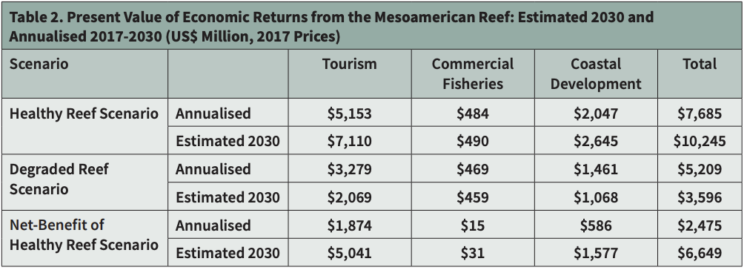
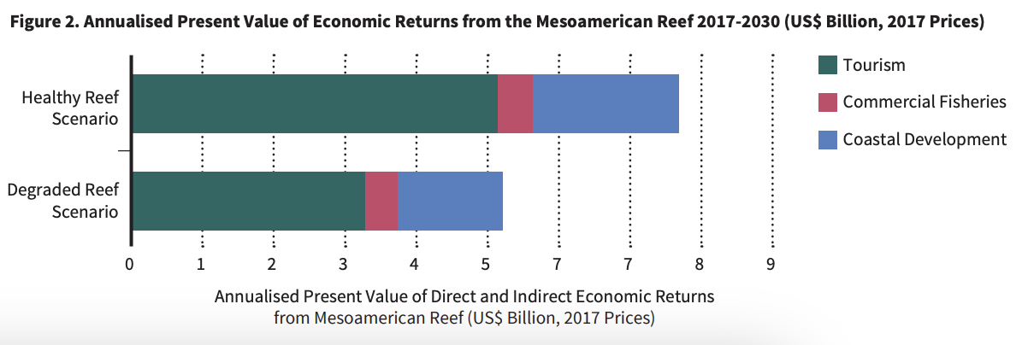
- Fig 3
  - Change in economic returns from Mesoamerican Reef Relative to 2017
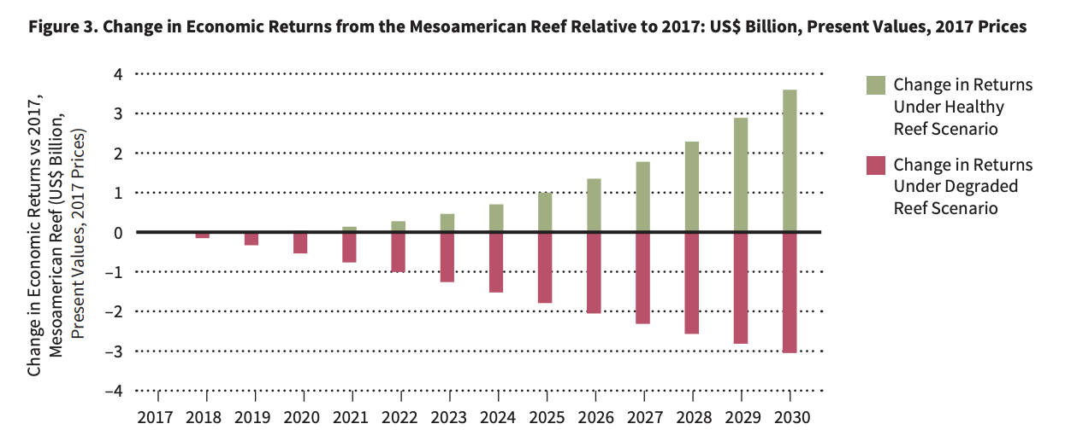
- Fig 4 and Table 3
  - Present annualised present value of economic returns from key sectors in Coral Triangle (2017-2030) under both scenarios

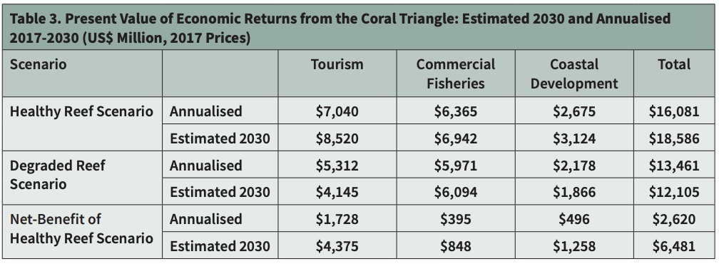
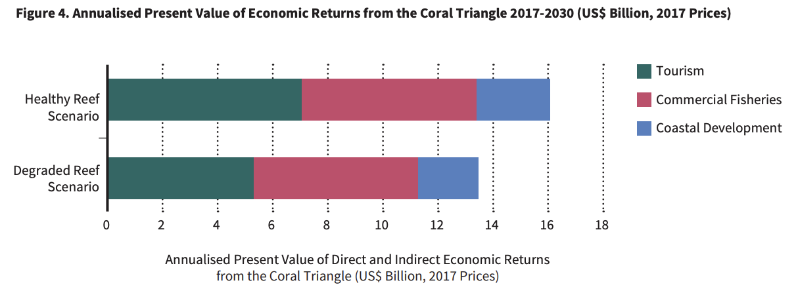

- Fig 5
  - Change in economic returns from Coral Triangle Relative to 2017

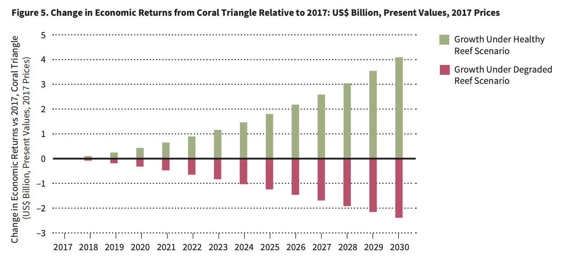

Intervention and Analysis Results
- Presents the results of a modelled analysis of a range of potential coral health interventions that could possibly be adopted to shift the status of coral reefs from current path towards healthy in the future
- Evaluation Criteria:
  - Expected impact of intervention on improving live coral cover rates
  - Expected costs of implementation and maintenance
  - Expected economic returns to the 3 key sectors associated with improving live coral cover in each case study relative to Degraded Reef Scenario
  - Expected economic net-benefit and return on investment for each intervention relative to Degraded Reef Scenario

Intervention Net-Benefits
- Fig 6 and table 4
  - Comparison of the estimated annualised costs, benefits and net-benefits of modelled interventions in Mesoamerica
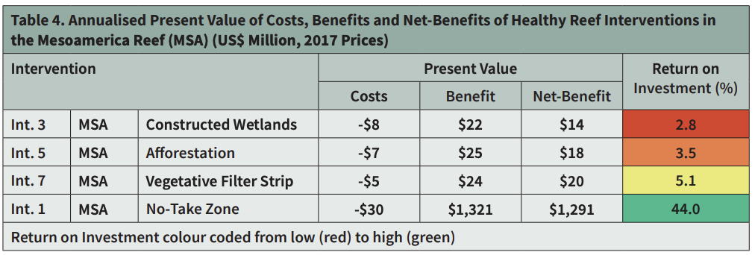
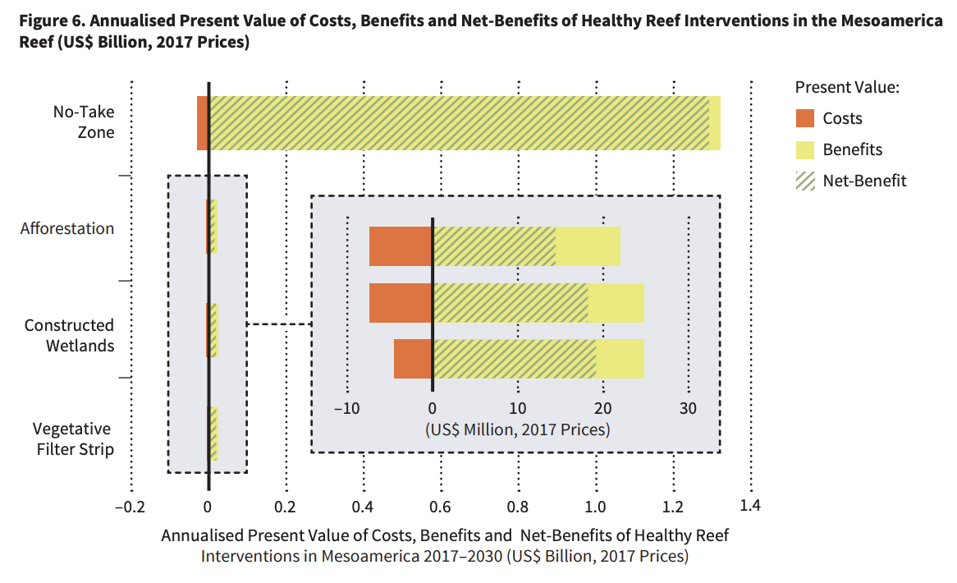
- Fig 7 and table 5
  - Comparison of the estimated annualised costs, benefits and net-benefits of modelled interventions in Coral Triangle
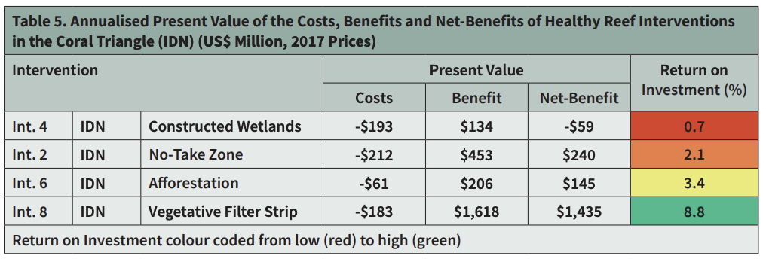
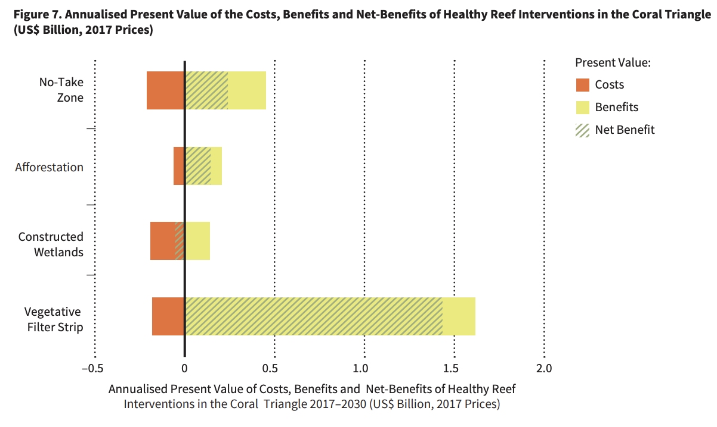
Expansion of No-Take Marine Protected Areas
- Fig 8 and Table 6
  - Estimated impact of interventions to expand coverage of no-take zones to 30% of total existing marine protected area in each region
  - Most important cost of no-take zones is the opportunity cost of forgone production due to exclusion of fishing within the zone
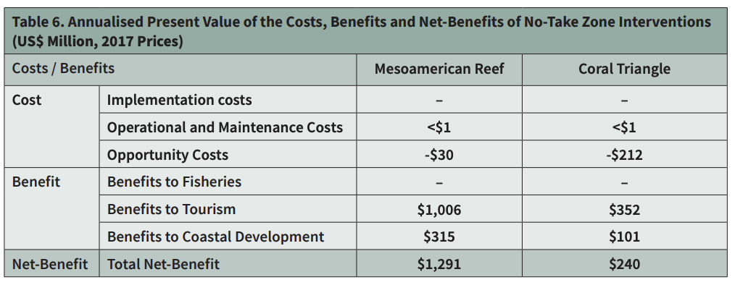
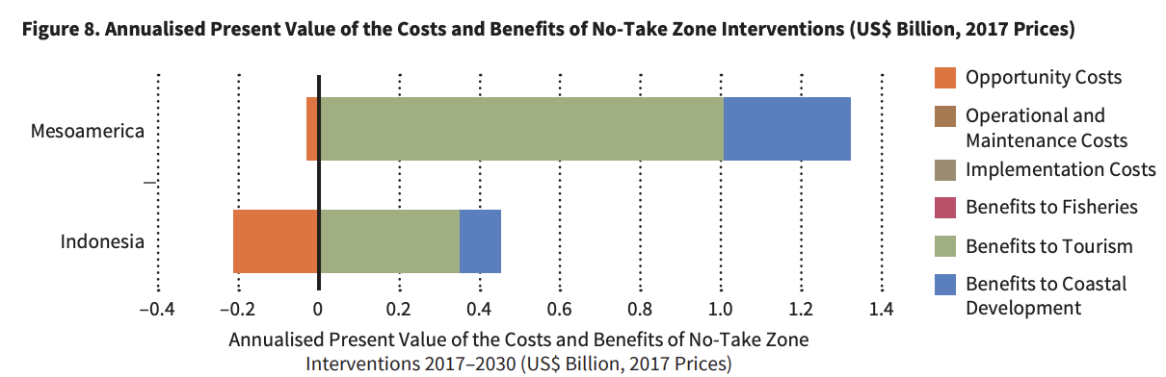
Constructed Wetlands for Enhanced Wastewater Management
- Fig 9 and Table 7
  - Estimated impact of interventions to expand access to municipal wastewater treatment through the construction of sufficient constructed wetlands capacity to treat 50% of the currently untreated wastewater in each region
    - Tables don’t consider the public health benefits and other environmental benefits due to the improved sanitation
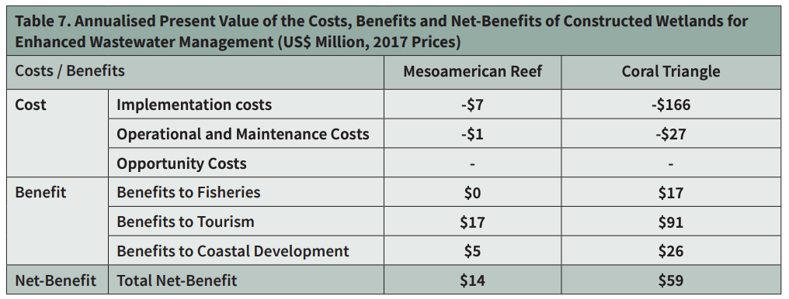
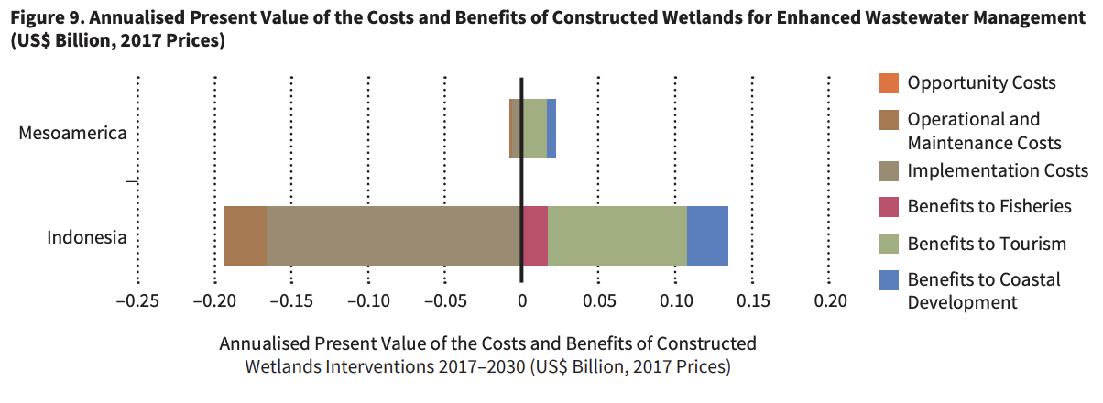
Afforestation to Reduce Erosion
Fig 10 and Table 8
  - Estimated impact of afforestation projects to increase forest cover on land within coastline
    - Helps reduce erosion rates on coastal land, reducing negative impact of sediment on coral health
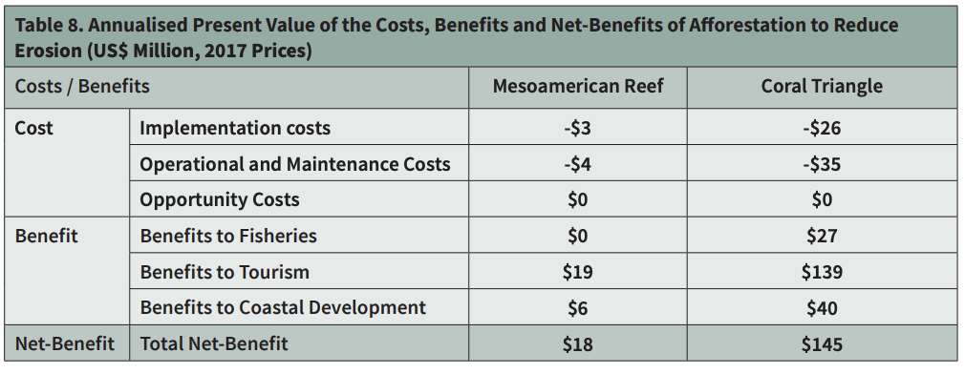
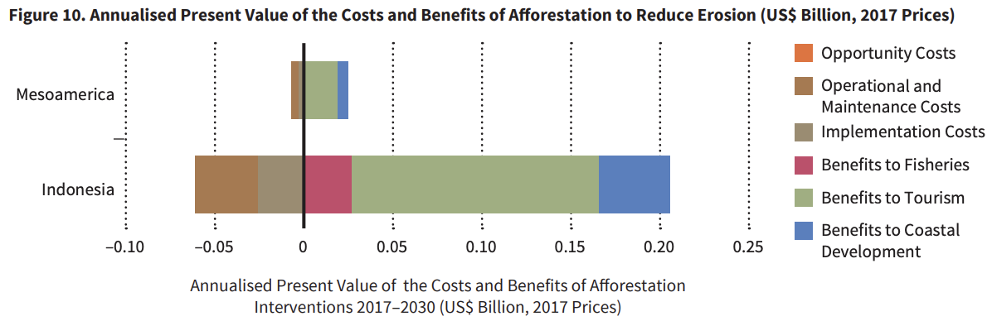
Vegetative Filter Strips to Reduce Erosion on Cropland
- Fig 11 and Table 9
  - Estimated impact of implementation of vegetative filter strips on agricultural land
    - Also helps reduce erosion rates
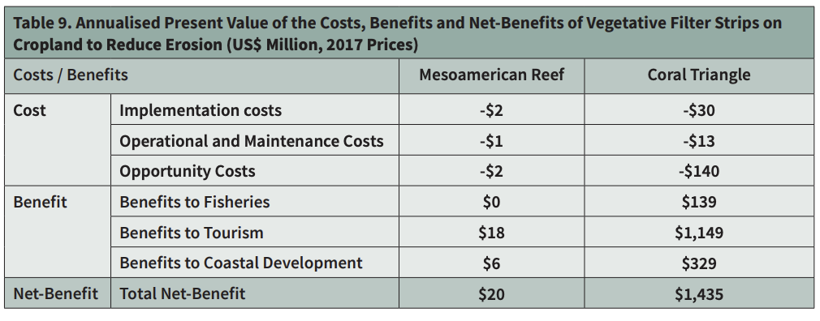
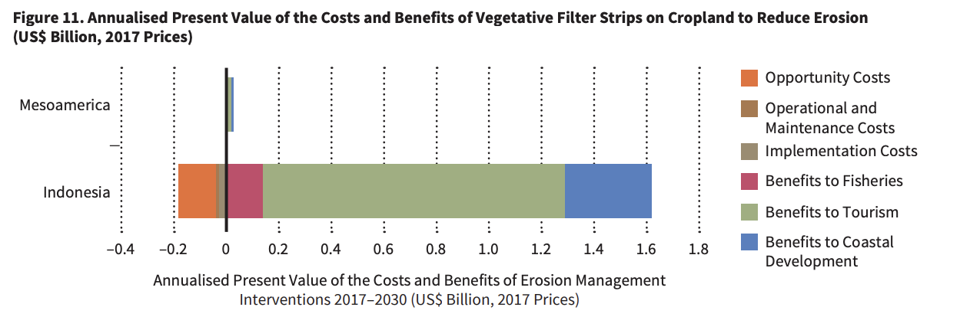

Toward a Healthy Reef Scenario
- Combines results of the scenario and intervention analysis to assess the degree to which the modelled interventions would assist in closing the gap between a Healthy and Degraded Reef
  - Majority contribution towards gap closer between degraded and healthy reef scenarios in the Coral Triangle are the adoption of vegetative filter strips
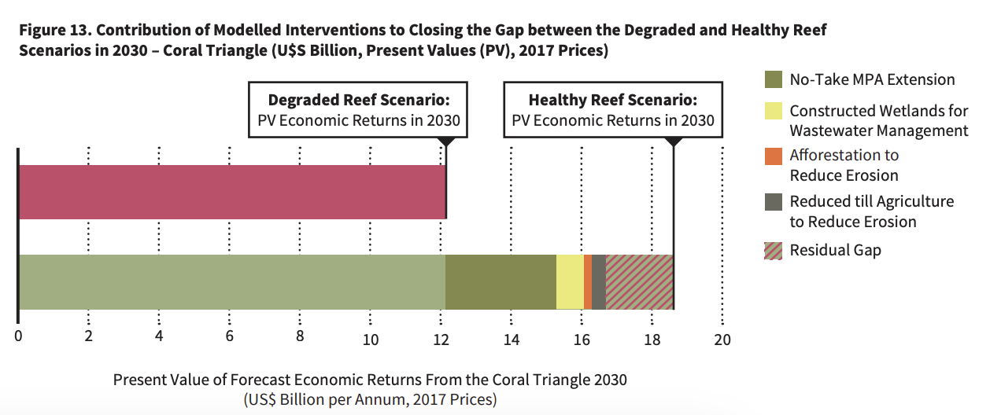

The Economics of Worldwide Coral Reef Degradation

Coral Bleaching and Climate Change
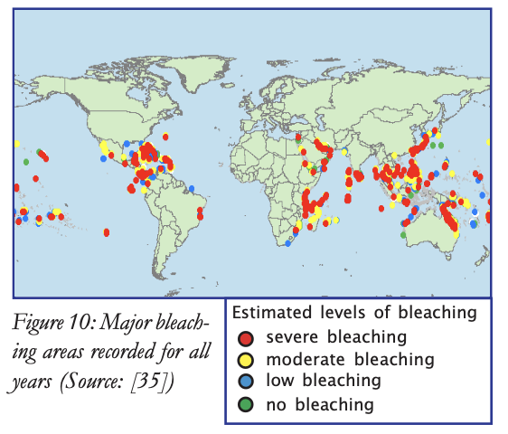
- Global Coral bleaching and coral morality likely will result in social-economic impacts
  - Study on the 1998 massive bleaching event estimated a loss of $700 - $8,200 million in net present value terms for the Indian Ocean

- “Hotspot frequencies” show a weak link with bleaching events
- Fig 11: cumulative number of hotspots over 16 years (1985-2000)
  - A hotspot is recorded when the temperature in a grid cell exceed the mean maximum temperature in that cell by a degree Celsius
- 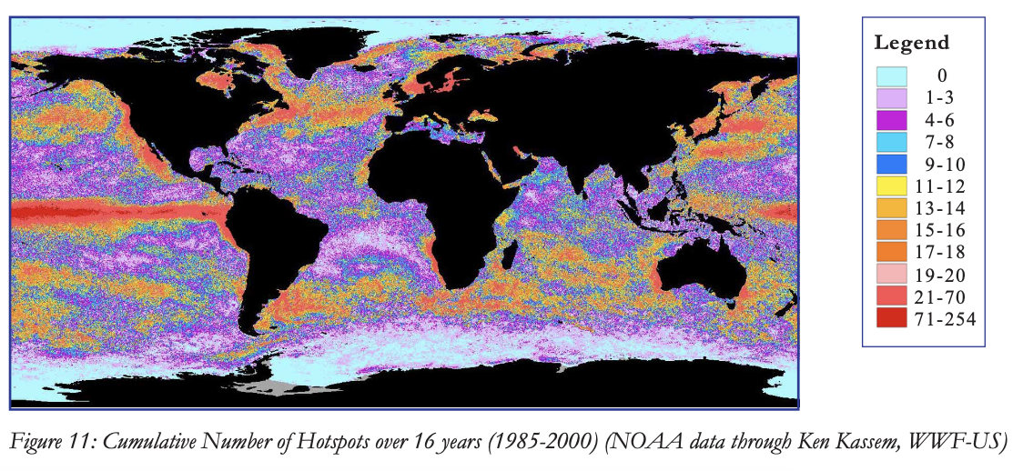
- Current estimates suggest a likely increase in frequency of bleaching as a result of climate change and predict bleaching could become an annual event in the next 25-50 years

2 Potential Scenarios Created
- Moderate
  - Corals bleach but morality is limited
  - Biodiversity values decline to 90% of their current level
- Severe
  - Mass coral mortality
  - Biodiversity value declines to 50% of their current value
- Fig 12
  - Shows the costs of bleaching distributed among sectors (in billions of US$)
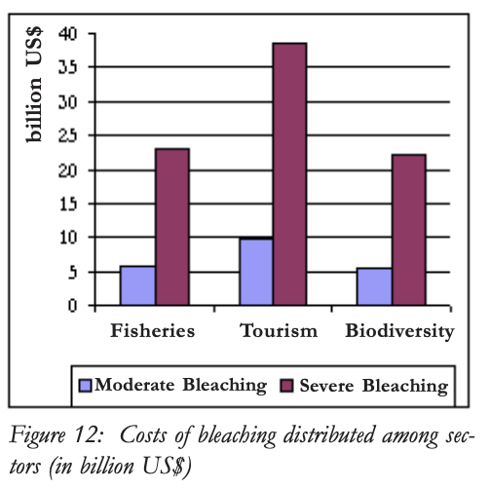
- Table 6
  - Regional allocation of costs of severe bleaching (in billions of US$)
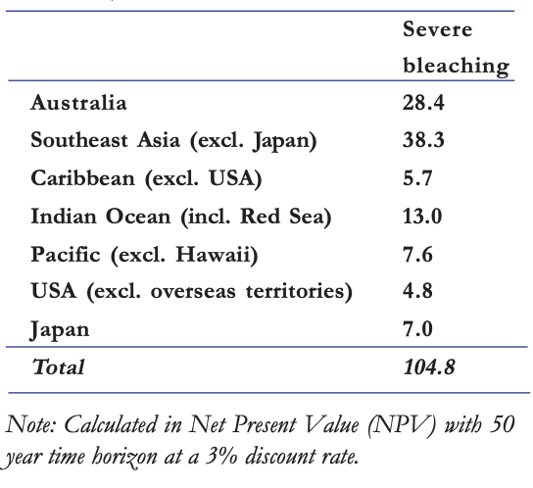
- Other additional impacts of climate change will also cause adverse impacts on coral reefs and their value
  - Increased hurricane activity
  - Natural disasters

- Possible that impacts of sea surface temperature changes on corals can be reduced by lowering overall stress level on coral reefs
  - Through concerted efforts by all stakeholders and in more main mainstream parts of international funding agencies’ activities in Caribbean and the Pacific
  - Concerted effort is required to ensure these efforts extend widely to other regions of the world and progress in addressing climate change is made

Climate Change Impacts on Tourism

- Tourism is seen as a climate-dependent industry
  - Climate change effects and impacts can be debilitating to the tourism industry in tourism dependent economies
  - Changes in temperature, water and drought issues, and changes in coral reefs are all affected by climate

- Table 1: Main Impacts of Climate Change and Implications
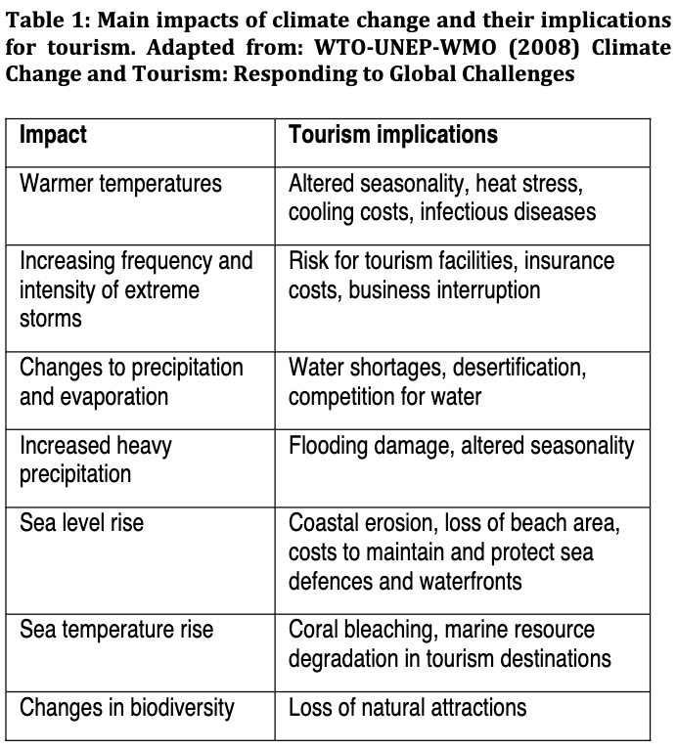
- Fig 1: Temperature Data 1880 and Beyond
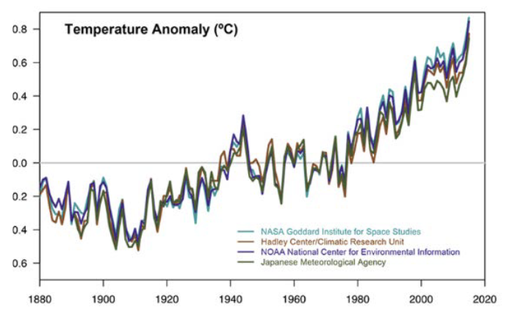
- Demonstrates the rapid warming reported within the past few decades and it further corroborates that the last decade has been the warmest recorded

Oceans and Coral Reefs
- Ocean temperatures are rising but ocean chemistry is also changing due to increased amount of carbon dioxide dissolving into the water
  - Results in ocean acidification
- Globally, the 3rd coral bleaching event was declared in October 2015 which lasted more than a year and extended into 2016
  - Coral generally survive shorter periods of bleaching, but this long period of bleaching can be fatal
- Coral bleaching and coral diseases have become more frequent
  - Magnitude of bleaching has increased and is expected to continue

